

Final Project – Phase A (61998)

ErgoMon
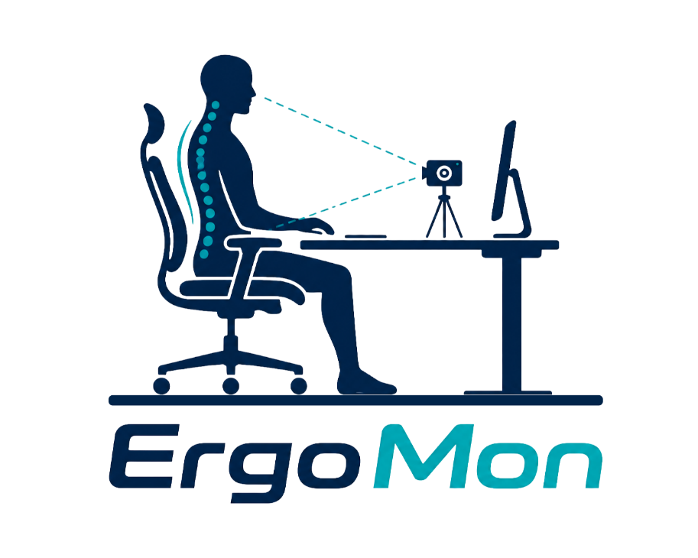
By:
Aya Saeed - Aya.saeed@e.braude.ac.il
Marwan Zayyad - Marwan.Zayyad@e.braude.ac.il
Advisor:
Dr. Reuven Cohen
Link to GitHub: https://github.com/AyaSaeed10/ergonomic-posture-monitoring-system

Table of Contents
1. Introduction: 2
1.1 Scope of the project: 3
1.1.1 Identification Model 3
1.2 Stakeholders: 3
1.3 Document Review: 3
2. Background and Literature Review 4
2.1 computer long setting problems: 4
2.2 Literature Review 4
2.2.1 Neck and Lower Back Pain Related to Computer Use 4
2.2.2 Human Skeleton Mapping and Pose Estimation 6
2.2.3 Machine Learning for Posture Classification 7
2.2.4 Existing Solutions and Limitations 7
3. Research / Engineering Process 7
3.1 Proposed Solution and Development Process 7
3.1.1 Overview of the Proposed Solution 7
3.1.2 Software Development Methodology 8
3.1.3 Stages in Research and System Development 8
3.2 System Requirements 8
3.2.1 Requirements Collection Process 8
3.2.2 Functional Requirements 9
3.2.3 Non-Functional Requirements 9
3.3 System Description and Operation 9
3.3.1 System Operation (General Workflow) 9
3.3.2 System Constraints 10
3.3.3 Prototype Implementation 10
3.3.4 Algorithms and Method 11
3.4 System Architecture and Design 12
3.4.1 Use-Case Diagram 12
3.4.2 High-Level System Architecture 13
3.4.3 Activity Diagram 13
3.5 Tools and Technologies 14
3.5.1 python 14
3.5.2 Firebase Firestore 14
3.5.3 Desktop/Web Interface 15
3.6 Future Embedded System Extension 15
3.7 Expected Challenges And Mitigation Strategies 16
3.8 Testing and Evaluation Process 16
3.9 Success Criteria 20
4. Use of Artificial Intelligence Tools 21
5. References 22

Abstract
Prolonged computer use has become a common part of modern life, often leading to physical discomfort and musculoskeletal issues. In particular, poor sitting posture, including incorrect neck alignment and improper lower back positioning, are major contributors to pain and long-term health problems among computer users.
This project focuses on the development of an intelligent ergonomic monitoring system that analyzes user’s upper body posture, including the head, neck, shoulders, and back posture during computer use. The system utilizes computer vision techniques with a side-positioned camera to capture body posture and extract skeletal landmarks using the MediaPipe framework.
Based on these landmarks, geometric features such as angles, distances, and symmetry measures related to the neck and lower back are extracted. A Random Forest classification model is then applied to identify improper posture patterns and detect potential ergonomic risks. The system provides real-time feedback and notifications based on posture behaviour over time, ensuring that alerts are triggered only when improper posture persists, to help users correct their posture and maintain proper alignment.
In addition, the system suggests appropriate break intervals and simple stretching exercises based on prolonged sitting behaviour, aiming to minimize physical discomfort and support healthier work habits. The application aims to increase user awareness, prevent posture-related discomfort, and promote healthier computer usage habits over time.

1. Introduction:
In recent years, the use of computers for work, study, and daily activities has significantly increased. As a result, many individuals spend prolonged periods sitting in front of screens, often without proper ergonomic awareness. This behaviour frequently leads to physical discomfort and musculoskeletal problems, particularly in the neck and lower back regions.
Incorrect neck posture, commonly known as forward head posture, and poor lower back posture are among the main causes of pain and long-term health issues during prolonged computer use. According to professional observations, including those from optometrists, many users experience discomfort such as eye strain and neck pain that are strongly related to improper posture rather than vision problems alone.
In this project, we propose an intelligent ergonomic monitoring system designed to analyze upper body posture, with a focus on the neck and lower back during computer use. The system utilizes a side-positioned camera and applies computer vision techniques to extract body landmarks. These landmarks are used to derive geometric features that reflect posture alignment. The system analyzes the extracted posture information to identify incorrect posture patterns.
The system provides real-time feedback to the user, alerting them when improper posture is detected based on posture behavior over time. In addition, it recommends appropriate break intervals and simple stretching exercises to reduce discomfort and encourage healthier work habits. The system aims to increase user awareness, prevent posture-related issues, and support long-term ergonomic well-being.

1.1 Scope of the project:
The goal of this project is to develop an intelligent system that monitors and evaluates user’s upper body posture, with a focus on the neck and lower back while working on a computer. The system acts as a virtual ergonomic assistant that operates in real time using a side-positioned camera.
The system detects the user’s body posture, derives geometric features, and evaluates posture quality across different posture categories based on predefined ergonomic thresholds. If improper posture is detected, the system provides immediate feedback and corrective suggestions based on posture behavior over time.
In addition, the system monitors prolonged sitting duration and provides recommendations for break intervals and stretching exercises. By doing so, the system aims to reduce the risk of discomfort and prevent the development of long-term musculoskeletal issues.
The project focuses on practical implementation using computer vision and machine learning techniques, integrating them into a functional and user-friendly application.

1.1.1 Identification Model
The system uses a side-positioned camera to monitor the user’s posture and capture video frames in real time. For each frame, the system extracts body landmarks using the MediaPipe framework, which provides a skeletal representation of the human body.
Based on these landmarks, geometric features such as angles between key body points (e.g., head, neck, and shoulders) and relative positions of the lower back are calculated. These features are then used as input for a Random Forest classification model.
The Random Forest model is trained to distinguish between correct and incorrect posture patterns based on labeled data. This approach allows the system to make robust decisions by combining multiple decision trees, improving classification accuracy and generalization.
The combination of pose estimation and machine learning enables the system to analyze posture more reliably than using geometric calculations alone.

1.2 Stakeholders:
The proposed system is relevant to a wide range of users who spend extended periods working on computers, including students, office workers, and software developers. These users are often exposed to poor ergonomic conditions that may lead to posture-related discomfort, particularly in the neck and lower back.
In addition, the system may be of interest to healthcare professionals, such as physiotherapists and ergonomics specialists, who aim to promote correct posture and prevent musculoskeletal problems.
Furthermore, organizations and workplaces can benefit from this system by improving employee well-being, reducing discomfort-related issues, and promoting healthier working environments.

1.3 Document Review:
This document is structured as follows:
- Chapter 2 (Background and Literature Review): Presents the clinical foundations of posture risks (OSHA and ROSA standards), and reviews existing solutions in computer vision (MediaPipe) and machine learning.
- Chapter 3 (Research / Engineering Process): Outlines the complete technical execution, including software methodology, system requirements, UML diagrams, architecture design, core technologies (Python and Firebase Firestore), and the testing framework.
- Chapter 4 (AI Tools Used in Development): Details the artificial intelligence and generative tools utilized to assist in coding, optimization, and documentation throughout the project.
- Chapter 5 (References): Contains the bibliography and academic sources cited throughout the report

2. Background and Literature Review

2.1 computer long setting problems:
In recent years, the extensive use of computers in daily life has led to a significant increase in sedentary behavior, especially among students, office workers, and software professionals. Many individuals spend long hours sitting in front of screens without proper ergonomic awareness or guidance.
This behavior often results in musculoskeletal discomfort, particularly in the neck and lower back regions. Improper neck positioning, commonly referred to as forward head posture, and insufficient support of the lower back are considered major contributors to pain and long-term health issues [1].
In addition, research indicates that forward head posture significantly increases the physical load on the cervical spine, which may lead to long-term damage and discomfort [2].
Professional observations, including those from physiotherapists, indicate that many users experience symptoms such as neck discomfort and general body pain shortly after beginning their work sessions. These issues are often related to incorrect posture and poor alignment between the user and the screen.
Therefore, there is a growing need for intelligent systems that can monitor posture in real time and provide feedback to help users maintain proper ergonomic alignment and prevent long-term health problems.

2.2 Literature Review

2.2.1 Neck and Lower Back Pain Related to Computer Use
Recent studies have shown that prolonged sitting and improper posture are major contributors to musculoskeletal disorders among computer users. A study conducted on software professionals identified the neck and lower back as the most affected body regions due to long hours of computer use [3].
In addition, research indicates that incorrect head positioning significantly increases the physical load on the cervical spine. For example, tilting the head forward at large angles increases the stress on the neck, which may lead to long-term damage [2].
Prolonged sitting also increases pressure on the lumbar spine, especially when posture is incorrect, which result in stiffness, muscle weakness, and chronic pain over time [1].
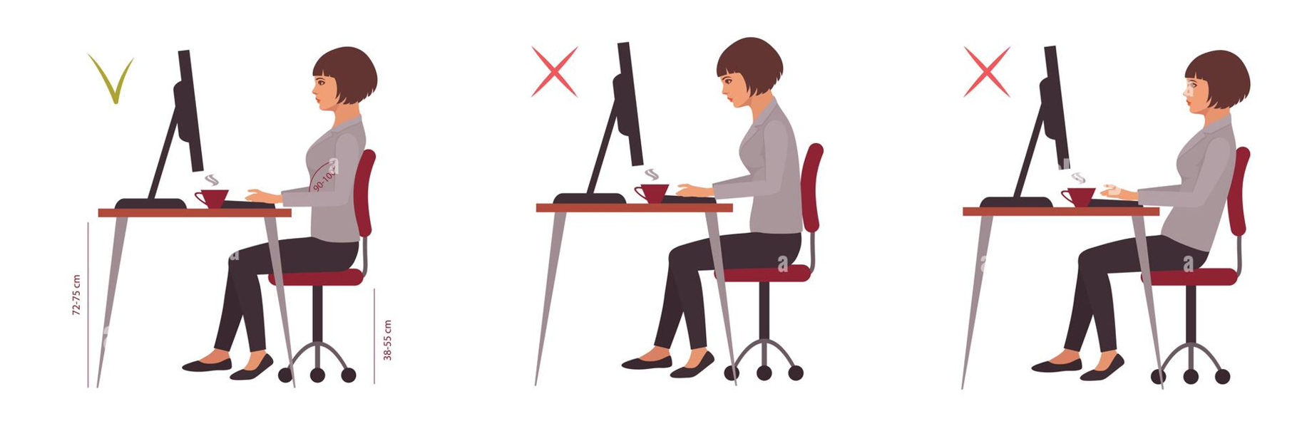
Figure 1: Examples of good and bad postures during computer use
Furthermore, studies show that regular stretching exercises can significantly reduce pain levels in the neck and lower back, highlighting the importance of integrating movement and breaks during prolonged computer use [3].
Based on international ergonomic standards, such as the Occupational Safety and Health Administration (OSHA) and the Rapid Office Strain Assessment (ROSA) framework, proper sitting posture is not entirely static but is defined within specific safe angular ranges. These benchmarks establish the biomechanical foundation for identifying postural risks. Table summarizes the recommended ergonomic angles and physical boundaries for the primary body regions focused on in this project: the neck and the lower back [7].

Targeted Body Region | Postural Parameter | Recommended Safe Zone | Biomechanical Significance & Risks
Neck / Head | Neck Flexion / Gaze Angle | 0°) - 20°)  (Downward) | Keeping the neck within 20° minimizes upper trapezius muscle strain. Bending beyond this range increases cervical spine load exponentially.
Lower Back (Trunk) | Upright Sitting | Exactly 90° (Vertical) | Maintains a neutral spine alignment and distributes upper body weight evenly across the lumbar vertebrae.
Lower Back (Trunk) | Reclined Sitting | 105° - 120° | Supported reclining at this angle significantly lowers intradiscal pressure in the lumbar spine (L4-S1) compared to a strict 90° posture.
Monitor Placement | Viewing Distance & Angle | 50 - 100 cm  / 15° - 20° | Placing the monitor centered, at arm's length, and slightly below eye level prevents neck rotation and reduces visual fatigue.
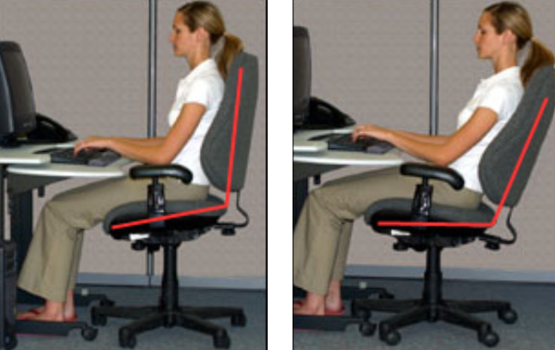
Figure 2: Recommended sitting postures showing a 90° upright position and a 105°–120° reclined position for optimal ergonomic support.

2.2.2 Human Skeleton Mapping and Pose Estimation
Human pose estimation is a key technology used for posture analysis, as it enables the detection of body keypoints such as the head, shoulders, and hips from images or video streams. These keypoints allow systems to analyze body alignment and posture.
Recent research demonstrates that pose estimation techniques are effective for real-time posture monitoring, especially when combined with computer vision systems [4].
In addition, angle-based posture recognition systems rely on detecting keypoints and calculating geometric relationships such as angles between joints to classify sitting posture [5].
Frameworks such as MediaPipe provide efficient real-time detection of body landmarks, making them suitable for ergonomic monitoring systems.
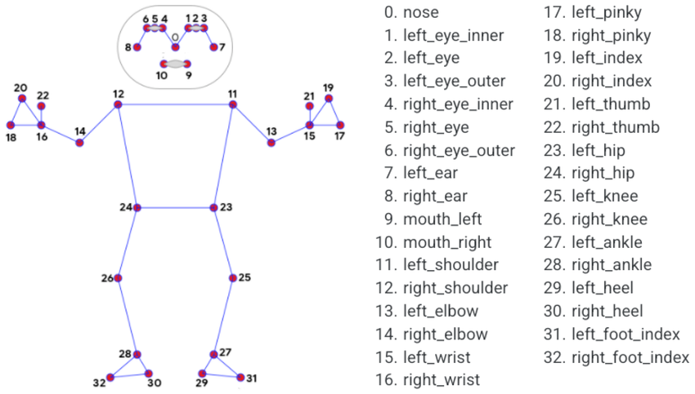
Figure 3: Example of body landmarks detected using MediaPipe.

2.2.3 Machine Learning for Posture Classification
Machine learning techniques are widely used for posture classification by analyzing features extracted from body landmarks, such as angles and distances between joints.
A recent study shows that angle-based features can effectively distinguish between correct and incorrect sitting posture, demonstrating that geometric analysis is a reliable approach for posture evaluation [5].
In addition, combining pose estimation with machine learning allows continuous monitoring of posture over time, improving the detection of incorrect sitting behavior in real-world scenarios [6].
Compared to deep learning approaches, traditional machine learning models such as Random Forest provide efficient and interpretable solutions that are suitable for real-time systems and require less computational resources.

2.2.4 Existing Solutions and Limitations
Existing posture monitoring systems often rely either on geometric calculations or on deep learning-based approaches. While geometric methods are simple and efficient, they may not always capture complex posture variations.
On the other hand, deep learning approaches can achieve high accuracy but require large datasets and significant computational resources, which limits their applicability in real-time systems.
Moreover, several studies highlight challenges such as occlusion (hidden body parts), noise in keypoint detection, and reduced accuracy in certain positions, especially when analyzing the back [6].
Therefore, there is a need for a system that combines pose estimation with efficient machine learning techniques, while focusing specifically on neck and lower back posture, to provide accurate and practical real-time feedback.

3. Research / Engineering Process

3.1 Proposed Solution and Development Process

3.1.1 Overview of the Proposed Solution
This project proposes an intelligent ergonomic monitoring system designed to analyze user’s upper body posture during computer use, with particular emphasis on the neck and lower back. The system addresses the widespread issue of poor sitting posture, which often leads to discomfort and long-term musculoskeletal problems due to prolonged computer usage.
The system operates by capturing the user’s posture through a side-positioned camera and analyzing it using computer vision and machine learning techniques. Based on this analysis, the system is able to identify improper posture patterns and provide real-time feedback to the user.
To improve usability, the system considers posture behavior over time and generates notifications only when necessary, avoiding excessive or unnecessary alerts. In addition, it may suggest short corrective actions or exercises during prolonged periods of sitting.
The main goal of the system is to increase user awareness, reduce posture-related discomfort, and promote healthier working habits during extended computer use.

3.1.2 Software Development Methodology
After examining common software development methodologies, the Waterfall model was selected for this project due to the following reasons:
- The project has a clearly defined scope and objectives.

- System requirements, algorithms, and testing plans are defined in advance.

- The structured nature of the project allows for sequential development stages.
Since the project is well-defined, the Waterfall methodology enables completion of each stage before moving to the next, ensuring stability and clarity throughout the development process.

3.1.3 Stages in Research and System Development
- Conducting focused research on neck and lower back posture problems caused by prolonged computer use, including identifying common posture mistakes such as forward head posture and poor lumbar support.

- Reviewing existing posture monitoring systems and analyzing their ability to detect neck angle and lower back alignment in real-time applications.

- Defining system requirements based on ergonomic guidelines, including acceptable neck angles, lower back alignment, and real-time feedback constraints.

- Selecting appropriate technologies, including a side-positioned camera for capturing user posture and the MediaPipe framework for extracting body landmarks.

- Designing the system architecture, including modules for video capture, pose estimation, feature extraction (angles), classification, and feedback generation.

- Selecting the Random Forest model as a classification approach based on its suitability for structured features such as angles and distances between body keypoints.

- Designing system components to provide real-time feedback, including posture alerts, break reminders, and stretching exercise recommendations.

- Integrating all system components into a unified application capable of analyzing posture continuously during computer use.

- Conducting system testing and evaluation to verify posture detection accuracy and real-time performance.

- Consulting with a physiotherapist to define correct posture ranges, validate system outputs, and identify appropriate stretching exercises and break intervals for users.

3.2 System Requirements

3.2.1 Requirements Collection Process
- Reviewing scientific literature related to ergonomics, posture analysis, and musculoskeletal issues caused by prolonged computer use.
- Analyzing existing posture monitoring systems and evaluating their functionalities, advantages, and limitations.
- Consulting with a physiotherapist to obtain professional insights on correct neck and lower back posture and common posture-related problems.
- Identifying user needs based on typical computer usage scenarios and prolonged sitting behavior.
- Deriving system requirements based on the collected information from literature, existing solutions, and expert consultation.

3.2.2 Functional Requirements
- The system will capture the user's posture in real time using a camera.

- The system will detect and track relevant body landmarks required for posture analysis.

- The system will extract geometric features (such as angles, distances, and symmetry measures) from the detected landmarks.

- The system will evaluate posture quality based on predefined ergonomic rules.

- The system will classify the user's posture into multiple predefined posture classes (e.g., correct posture, forward head posture, tilted head, etc.).

- The system will analyze the user's posture over time to identify persistent and recurring posture problems.

- The system will provide real-time feedback when incorrect posture is detected.

- The system will generate alerts only when necessary, avoiding excessive or unnecessary notifications.

- The system will recommend personalized stretching or corrective exercises based on the detected posture issues and the user's posture history.

- The system will monitor the duration of continuous sitting.

- The system will maintain a personal posture history for each user.

- The system will generate a personalized posture score based on ergonomic assessment.

- The system will provide personalized long-term recommendations based on the user's posture history.

3.2.3 Non-Functional Requirements

- The system will operate in real time with minimal delay in feedback.

- The system will maintain a processing rate of approximately 5–10 frames per second.

- The system will provide accurate posture classification under typical indoor conditions.

- The system will be user-friendly and require minimal user interaction.

- The system will generate clear and understandable feedback for the user.

- The system will avoid excessive or unnecessary notifications.

- The system will operate using standard hardware without requiring specialized equipment.
- The system will function effectively with a side-positioned camera setup.
- The system will ensure consistent performance across different users and environments.

3.3 System Description and Operation

3.3.1 System Operation (General Workflow)
- Capturing the user’s posture in real time using a side-positioned camera.
- Extracting body landmarks from the captured frames using computer vision techniques.
- Deriving geometric features from the extracted landmarks, including angles, distances, and symmetry measures.
- Evaluating posture quality using predefined ergonomic rules.
- Applying a machine learning model to classify posture patterns and detect incorrect posture.
- Performing temporal analysis to determine whether improper posture persists over time.
- Generating real-time feedback and corrective suggestions for the user.

3.3.2 System Constraints
During the development of the ergonomic posture monitoring system, several constraints must be considered.
One of the main constraints is the camera positioning. The system relies on a side-positioned camera to capture the user’s posture, as this viewpoint provides the most accurate representation of neck angle and lower back alignment.
In addition, the distance between the user and the camera must be consistent (approximately 1.5–2 meters) to ensure accurate detection of body landmarks and reliable posture classification.
Another constraint is the dataset collection process. The training data must include examples of both correct and incorrect posture, with proper labeling based on neck and lower back alignment. The dataset will consist of both real and synthetically generated samples to improve diversity and robustness. During real data collection, the camera will be slightly repositioned to simulate natural variations in camera placement between different users, while synthetic data augmentation will further improve the model's ability to generalize.
Camera placement side is another important consideration. Since the training dataset is collected using a single side-view perspective, placing the camera on the opposite side may affect posture analysis. To address this, the captured image will be horizontally mirrored before pose estimation, allowing the system to support both left- and right-side camera placement while maintaining consistency with the training data.
The system must also operate under real-time constraints, meaning that posture analysis and feedback should be provided instantly without noticeable delay. Therefore, efficient algorithms and lightweight models such as Random Forest are preferred.
Finally, the system should be able to run on standard computing devices without requiring specialized hardware, ensuring accessibility and usability for a wide range of users.

3.3.3 Prototype Implementation
A functional prototype of the proposed posture monitoring system was implemented using Python, OpenCV, and MediaPipe Pose. The prototype was designed to analyze the user’s posture in real time using a side-view camera setup.
The system captures live video from a webcam or GoPro camera and processes each frame using MediaPipe Pose in order to detect body landmarks such as the ear, shoulder, hip, and knee. The prototype relies on engineered posture features extracted from landmark coordinates rather than direct image classification.
Two main posture features were implemented:
- Neck angle (ear → shoulder → hip)

- Torso/back angle (shoulder → hip → knee)
These angles are calculated in real time and displayed on the screen together with visual debugging lines connecting the relevant body points. The prototype continuously classifies the user’s posture into:
- Good1

- Bent Forward

- Bent Backward
for both the neck and the back independently.
In order to determine reliable posture ranges, a dedicated data collection tool was implemented. During calibration, multiple samples of correct sitting posture were collected while slightly moving naturally. The collected neck and torso angles were analyzed statistically using percentile-based filtering in order to reduce the effect of incorrect MediaPipe detections or noisy frames.
The resulting calibrated ranges were then used to implement a rule-based posture classification system capable of detecting incorrect neck and back positions in real time.

3.3.4 Algorithms and Method
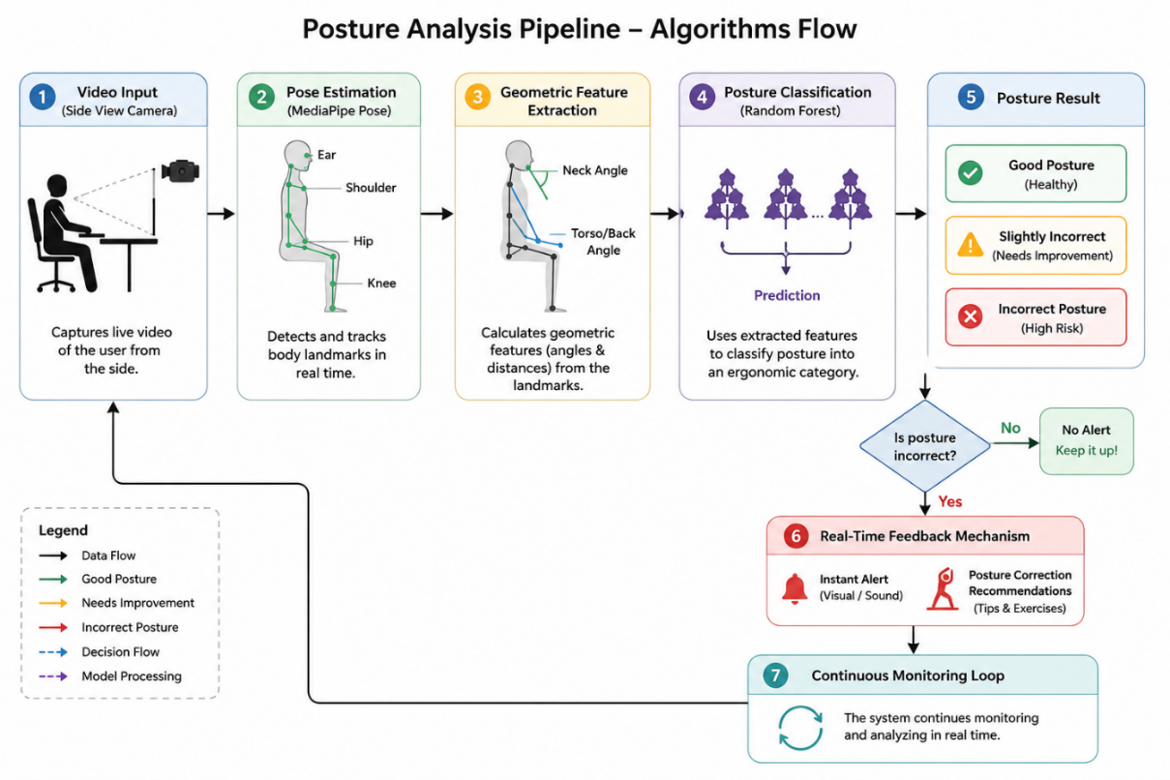
Figure 4 : Overall workflow of the proposed posture monitoring system.

MediaPipe Pose Estimation
MediaPipe Pose is used to detect and track the user’s body landmarks in real time using a side-view camera. The framework extracts important body points such as the ear, shoulder, hip, and knee, which are later used for posture analysis. MediaPipe was selected due to its high accuracy and ability to operate efficiently in real-time environments.
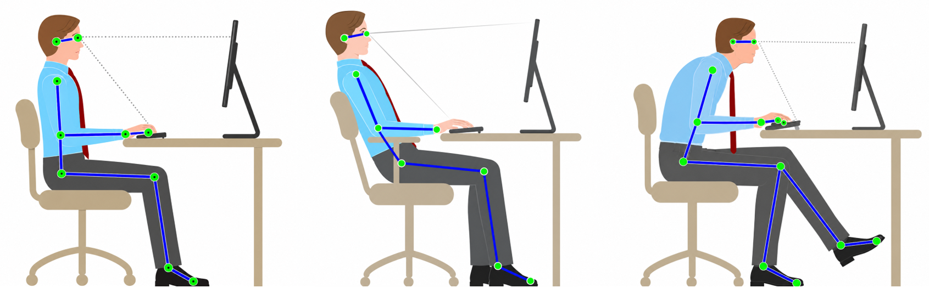
Figure 5: Examples of the posture categories analyzed by the proposed system.

Geometric Feature Extraction
After detecting the body landmarks, the system calculates geometric posture features such as neck angle and torso/back angle. These measurements provide a mathematical representation of the user’s posture and are used as input for the posture classification model.

Random forest:

While scikit-learn provides the broader machine learning infrastructure, Random Forest is the specific ensemble learning algorithm chosen to power the core classification model. It was selected because posture detection relies on multiple, highly correlated geometric metrics—such as shoulder-to-ear angles, back inclination, and lateral tilt. Random Forest handles these ` complex, non-linear relationships by combining the predictions of multiple decision trees, which prevents the system from overfitting to a single user's body type or camera angle. In the live pipeline, the algorithm simultaneously evaluates all extracted angle and distance measurements, making a highly reliable consensus decision to instantly classify the user's posture into a specific ergonomic category.
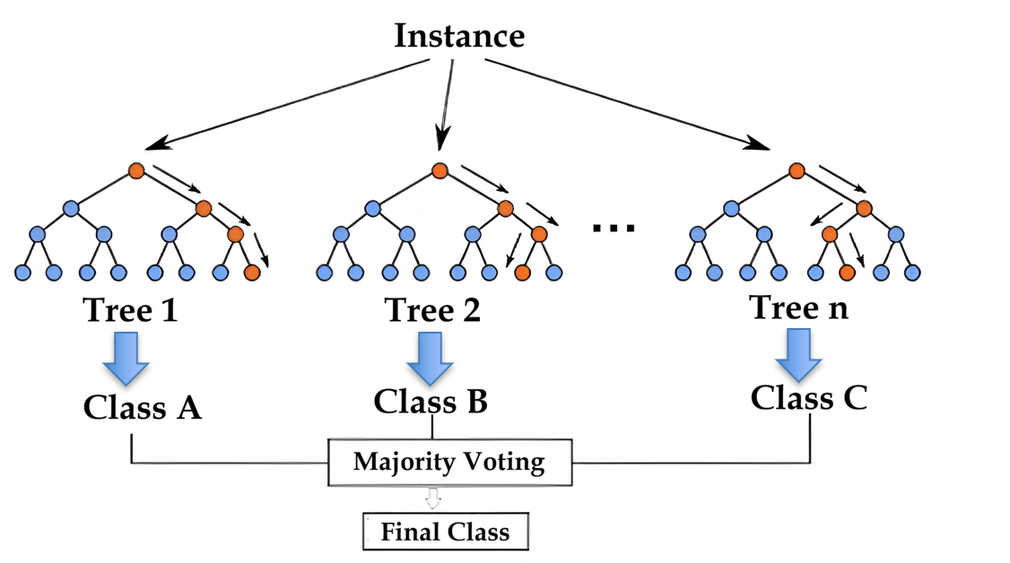
Figure 6: Random Forest classification based on multiple decision trees and majority voting.

Real-Time Feedback Mechanism
The system provides immediate ergonomic feedback whenever incorrect posture is detected. Based on the classification result, real-time alerts and posture correction recommendations are displayed to help the user maintain healthier sitting habits.

3.4 System Architecture and Design

3.4.1 Use-Case Diagram
This diagram illustrates the main functionalities available to the user within the ErgoMon system. It shows how the user can monitor posture, receive real-time feedback and alerts, manage personal information, and review daily summaries and progress reports.
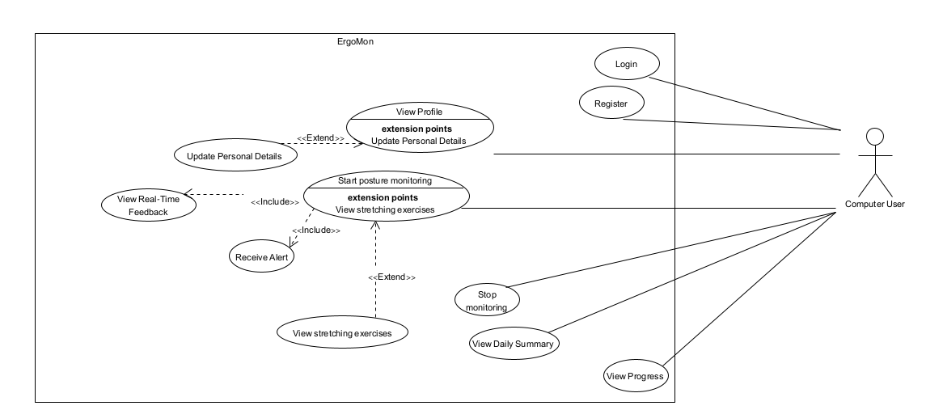
Figure 7: Use-case diagram

3.4.2 High-Level System Architecture
This diagram presents the overall structure of the ErgoVision system. The client side handles user interaction and camera access, while the server processes posture data using pose detection, feature extraction, and machine learning techniques. The dataset is used to train and support the posture classification model.
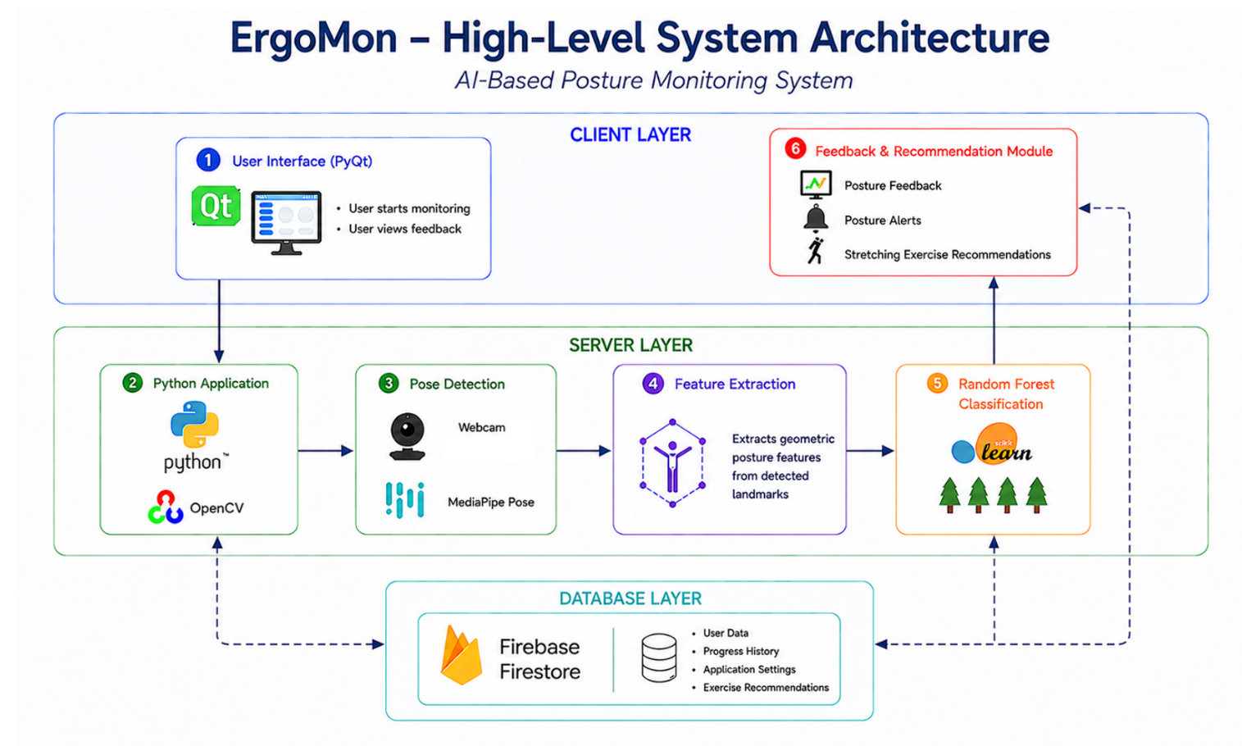
Figure 8: High-Level System Architecture

3.4.3 Activity Diagram
This diagram describes the workflow of the posture monitoring process. The system captures video frames, analyzes the user's posture, generates feedback when needed, and continues monitoring until the session ends. At the end of the session, the system stores the collected data and feedback for future.
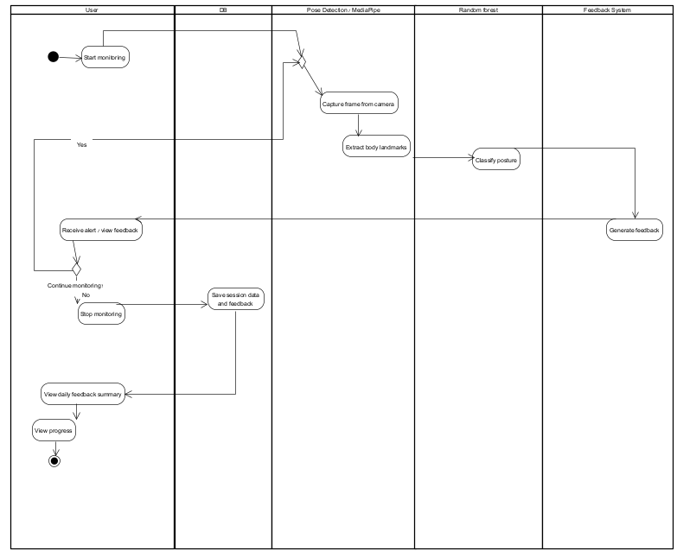
Figure 9: Activity Diagram

3.5 Tools and Technologies

3.5.1 python
Python will be utilized as the primary programming language for developing the proposed posture monitoring system. The language was selected for its flexibility, cross-platform compatibility, and robust support for data science and automation. Within the proposed system, Python serves as the central integration layer, orchestrating the real-time processing pipeline by connecting the following core components:

- OpenCV Video Processing: Managing communication with the workstation’s webcam, handling real-time video frame acquisition, and preparing the visual input before it enters the posture analysis pipeline.

- MediaPipe Pose Analysis: Processing incoming video frames and extracting the body landmark coordinates required for geometric posture analysis and posture classification.

- Machine Learning Integration: Coordinating the posture classification workflow using scikit-learn and Random Forest models to analyze the extracted geometric posture features in real time.

3.5.2 Firebase Firestore
Firebase Firestore will be utilized as the cloud database solution for storing and managing application data within the proposed system. The platform was selected due to its real-time synchronization capabilities, scalability, and straightforward integration with Python-based applications. Within the proposed system, Firestore will manage user information, application settings, posture-related recommendations, and exercise data, while also enabling remote content updates by the system administrator without modifying the client-side application.

3.5.3 Desktop/Web Interface
The Desktop/Web Interface will serve as the primary interaction layer between the user and the proposed posture monitoring system. The interface will be responsible for presenting posture analysis results, real-time alerts, posture statistics, and ergonomic recommendations in a clear and accessible manner, while also allowing users to review posture-related information and corrective suggestions during system operation.

3.6 Future Embedded System Extension
As a possible future extension of the proposed system, the posture monitoring application may later be adapted into a standalone smart device using an embedded computing platform such as Raspberry Pi. The goal of this approach is to transform the current desktop-based solution into a portable and dedicated real-time posture monitoring system.
The embedded architecture may include the following hardware components:
- Raspberry Pi embedded computer
- Camera for real-time posture monitoring
- Small external display or touchscreen for user interaction and posture feedback
- Optional portable battery-powered setup
The embedded version would operate using the same core posture analysis pipeline developed for the desktop environment, including body landmark detection, geometric feature extraction, machine learning classification, and real-time posture feedback. In this architecture, the machine learning model would be trained externally on a regular computer, while the Raspberry Pi would only perform real-time inference and posture monitoring.
This modular approach would allow the proposed system to evolve into a compact standalone ergonomic monitoring device without requiring major modifications to the core software architecture.
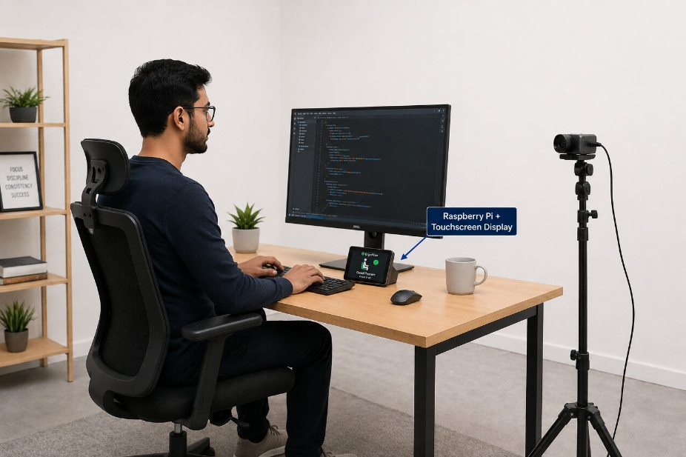
Figure 10: Future embedded ErgoMon system concept.

3.7 Expected Challenges And Mitigation Strategies
Choosing a Pose Estimation model
Different pose estimation models provide varying levels of accuracy and computational efficiency. If the selected model does not provide sufficient landmark quality, alternative pose estimation models or additional derived landmarks will be evaluated.
Hardware limitations
Training the machine learning model may require higher computational resources than a standard personal computer can provide. If local hardware proves insufficient, cloud computing platforms such as Google Colab will be used to accelerate the training process.
Dataset Availability
Existing public datasets may not adequately represent side-view neck and lower back postures required for this project. If suitable data cannot be obtained, a custom dataset will be collected and manually labeled to meet the project requirements.
Variability between users
Differences in body dimensions, sitting habits, and camera positioning may affect posture measurements. To improve the model's ability to generalize, data will be collected from multiple participants with diverse physical characteristics and sitting styles.
Defining correct posture
Establishing reliable boundaries between correct and incorrect posture requires accurate reference data. To ensure correct labeling, posture samples will be verified using ergonomic guidelines and, where necessary, reviewed with the assistance of a physiotherapist.
Lighting and camera conditions
Variations in lighting, camera quality, or background environments may reduce landmark detection accuracy. If this issue is observed, image preprocessing and enhancement techniques will be applied to improve the robustness of pose estimation.
Camera Viewpoint Limitations
A single side-view camera may not always capture all body landmarks or provide sufficient information to accurately evaluate every posture. If certain postures or body angles cannot be reliably analyzed from a single viewpoint, additional cameras will be incorporated to provide multiple viewing angles and improve posture assessment accuracy.

3.8 Testing and Evaluation Process
Test #1: User Login
Test Case Description |  | Successful Login into the ErgoMon system
# | Action | Input | Expected Result
1 | Lunch ErgoMon system | Run Client / Open ErgoMon website | Index page.
2 | Enter email and password | Email= User@gmail.com  password = ****** | valid credentials detected.
3 | Press login | Mouse click | User dashboard appers

Test #2: Start Monitoring Session
Test Case Description |  | Start real-time posture monitoring
# | Action | Input | Expected Result
1 | Open monitoring page | Click "Start monitoring" | Camera initialization
2 | Enter email and password | Side camera | Live video stream appears
3 | Press login | Mouse click | Real-time posture analysis starts

Test #3: Camera Detection
Test Case Description |  | Verify side camera connection
# | Action | Input | Expected Result
1 | Connect Camera | Side camera | Camera connected successfully
2 | Start video stream | User sitting beside camera | User appears clearly in frame
3 | Check side angle | Side posture view | Neck and back visible correctly

Test #4: Pose detection using Media Pipe
Test Case Description |  | Detect body Landmarks correctly
# | Action | Input | Expected Result
1 | Start monitoring session | User seated normally | Pose estimation window opns
2 | Capture body landmarks | Neck ,shoulder ,hip landmarks | Landmarks detected successfully
3 | Verify skeleton drawing | User posture frame | Skeleton appears correctly on user body

Test #5: Feature Extraction
Test Case Description |  | Calculate posture angels correctly
# | Action | Input | Expected Result
1 | Detect landmarks | Nose , shoulder , hip points | Coordinates extracted
2 | Calculate neck angle | Landmark coordinates | Correct neck angle calculated
3 | Calculate back angle | Landmark coordinates | Correct Lower-back angle calculated

Test #6: Posture Classification
Test Case Description |  | Classify posture using Random Forest model
# | Action | Input | Expected Result
1 | Send extracted features | Angels and posture measurements | Features processed
2 | Run Random Forest model | Feature vector | Posture classified
3 | Display result | Good/Bad posture | Correct posture state shown with feedaback

Test #7: Incorrect Neck Posture Alert
Test Case Description |  | Detect forward head posture
# | Action | Input | Expected Result
1 | User bends neck forward | Incorrect neck angle | Incorrect posture detected
2 | Continue monitoring | Real-time video | Alert triggered
3 | Display feedback | "Straighten your neck" | Alert message appears on screen

Test #8: Incorrect lower Back Posture Alert
Test Case Description |  | Detect Lower-back slouching
# | Action | Input | Expected Result
1 | User slouches | Incorrect back angle | Bad posture detected
2 | Continue monitoring | Real-time video | Warning generated
3 | Display feedback | "Sit upright" | Alert appears correctly

Test #9: Real-Time Feedback System
Test Case Description |  | Provide live posture feedback
# | Action | Input | Expected Result
1 | Start monitoring | User sitting in front of camera | Monitoring begins
2 | Detect posture state | Correct/ Incorrect posture | System analyses posture
3 | Show Live feedback | Feedback messages | Real-time recommendations displayed

Test #10: Daily Feedback Summary
Test Case Description |  | Generate daily posture report
# | Action | Input | Expected Result
1 | Finish monitoring session | End session button | Session saved
2 | Open feedback summary | Click "Daily Summary" | Feedback report page appears
3 | View posture Statistics | Alerts and posture history | Daily report displayed correctly

Test #11: Recommendations & Exercises
Test Case Description |  | Show posture improvement recommendations
# | Action | Input | Expected Result
1 | Detect repeated bad posture | Multiple alerts | Recommendation generated
2 | Open recommendations page | Mouse click | Exercise suggestions appear
3 | View exercises | Stretching recommendations | Correct ergonomic exercises displayed

Test #12: Database Logging
Test Case Description |  | Save monitoring results into database
# | Action | Input | Expected Result
1 | Start monitoring session | User posture data | Recommendation generated
2 | Generate alerts | Incorrect posture events | Alerts saved
3 | End session | Session completed | Monitoring history stored in DB

Test #13: View Monitoring History
Test Case Description |  | Display previous monitoring session
# | Action | Input | Expected Result
1 | Open history page | Click "History" | Monitoring history page opens
2 | Select previous | Data selection | Relevant session displayed
3 | View session details | Posture logs and feedback | Detailed report shown

Test #14: System performance
Test Case Description |  | Verify real-time system responsiveness
# | Action | Input | Expected Result
1 | Start monitoring | Live video stream | System responds immediately
2 | Change posture quickly | Rapid movement | System updates posture state in real time
3 | Check delay | Continuous monitoring | Feedback appears with minimal delay

3.9 Success Criteria
Posture Detection Accuracy:
The ErgoMon system should achieve at least 95% classification accuracy in detecting incorrect neck and lower back posture using MediaPipe landmarks and the Random Forest classification model. The system is expected to correctly classify posture states in real time with reliable results.
High detection accuracy is essential because incorrect posture classification may lead to inaccurate ergonomic feedback and recommendations, reducing the effectiveness of the system.
Achieving high accuracy ensures that users receive reliable posture assessments and appropriate corrective guidance, increasing the overall effectiveness of the system.
System Responsiveness:
The platform should analyze the user's posture and generate feedback within one second to ensure smooth real-time monitoring and immediate ergonomic assistance during computer usage.
Slow response times may delay posture correction, allowing users to maintain unhealthy sitting positions for longer periods.
Fast system responsiveness enables immediate feedback, helping users correct their posture as soon as improper sitting is detected.
Real-Time Feedback Effectiveness:
The system should provide clear and useful real-time alerts whenever incorrect posture is detected, such as forward head posture or lower back slouching, within one second of detection. If alerts are unclear or delayed, users may ignore them or fail to correct their posture in time.
Providing timely and understandable feedback encourages users to respond immediately and maintain healthier sitting habits.
Daily Feedback Summary Reliability:
At the end of each monitoring session, the system should generate an accurate daily feedback summary that includes posture statistics, posture score, alerts history, and personalized ergonomic recommendations.
Incomplete or inaccurate summaries may prevent users from understanding their posture habits and tracking long-term improvement.
Reliable summaries allow users to monitor their progress, recognize recurring posture issues, and make informed adjustments to improve their ergonomic behavior.
Positive User Feedback:
At least 85% of users and ergonomic specialists participating in the evaluation should rate the ErgoMon system as useful, reliable, and easy to use for improving sitting posture during prolonged computer use.
If users find the system difficult to use or unreliable, they are less likely to continue using it regularly.
Positive feedback from both users and physiotherapists demonstrates that the system provides practical value and effectively supports healthier sitting habits.

4. Use of Artificial Intelligence Tools
ChatGPT:
- "Provide a literature review on computer vision-based posture monitoring systems and suggest recent academic papers on the topic."
- "Compare MediaPipe Pose, OpenPose, and YOLO-based approaches for real-time human posture detection."
- "Suggest measurable success metrics for a real-time posture monitoring system."
- "Generate functional and non-functional requirements for an AI-based posture monitoring application."
- "Create a high-level system architecture for a posture monitoring system using OpenCV, MediaPipe, and Machine Learning."
- "Suggest suitable machine learning algorithms for posture classification using body-angle features."
- "Review the proposed project architecture and identify potential technical challenges."

Perplexity AI:
- "Find recent academic sources related to sitting posture assessment using computer vision."
- "Summarize the main approaches used in posture correction systems."

ResearchRabbit:
- "Explore related research papers connected to computer vision posture monitoring."
- "Identify influential papers and citation relationships in the posture analysis domain."

NotebookLM:
- "Summarize the uploaded research papers and extract key findings relevant to posture detection."
- "Compare methodologies and datasets used by different studies."

5. References
[1] Jain, S., "How to Fix Lower Back Pain from Sitting", Pain Treatment MD, (2025).
Retrieved from: https://paintreatmentmd.com/blog/how-to-fix-lower-back-pain-from-sitting/

[2] Hansraj, K. K., "Assessment of Stresses in the Cervical Spine Caused by Posture and Position of the Head", Surgical Technology International, (2014).
Retrieved from: https://pingeprii.ee/wp-content/uploads/2016/09/Hansray-K.K.- Assessment-of-Stresses-in-the-Cervical-Spine-Caused-by-Posture-and-Position-of-the-Head.pdf

[3] Parthasarathi, V., Ranganathan, B., "Effect of scheduled stretching exercises in reducing musculoskeletal disorder symptoms among software professionals", Work: A Journal of Prevention, Assessment & Rehabilitation, (2025).
Retrieved from: https://journals.sagepub.com/doi/10.1177/10519815251399665
[4] Sahoo, K. K., Patel, T., Swain, D., Gerogiannis, V. C., Kanavos, A., Singh, D. P., Kumar, M., Acharya, B., "ALIGN: An AI-Driven IoT Framework for Real-Time Sitting Posture Detection", Algorithms, (2026).
Retrieved from: https://www.mdpi.com/1999-4893/19/1/48

[5] Agrawal, A., Sharma, M., Shakya, U., Sethi, S., Gupta, R., "Angle-Based Sitting Posture Recognition System", IIIT Kota, (2021).
Retrieved from: https://www.researchgate.net/profile/Manish-Sharma-190/publication/391527950_Angle-Based_Sitting_Posture_Recognition_System/links/68407aa66b5a287c3049350c/Angle-Based-Sitting-Posture-Recognition-System.pdf

[6] Hsieh, Y.-C., Sun, Y., "An Intelligent Mobile Application to Monitor and Correct Sitting Posture Using Raspberry Pi and MediaPipe Pose Detection", Pacific American School; California State Polytechnic University, Pomona, (2025).
Retrieved from: https://arxiv.org/html/2508.11683

[7] Occupational Safety and Health Administration (OSHA), "Computer Workstations eTool: Good Working Positions," U.S. Department of Labor. Available: https://www.osha.gov/etools/computer-workstations/positions[Accessed: June 2026].

